**Concurrent Non-Blocking Priority Queue Implementation**

CS 550 Advanced Operating System

**Pradyot Mayank (A20405826)**

**Nilesh Jorwar (A20405042)**

**Evaluation**

The evaluation of this project is comprised by the following:

**Case 1**: Average Response Time for Enqueue Operation at the Server Side for the no of Clients.

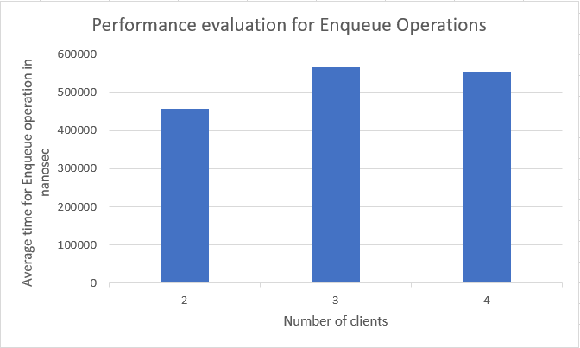

**Case 2**: Average Response Time for Dequeue Operation at the Server Side for the no of Clients.

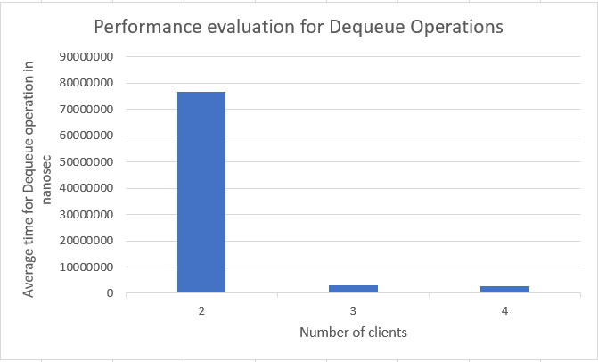

**Case 3**: Average Response Time for Enqueue Operation at the server side for the number of clients.

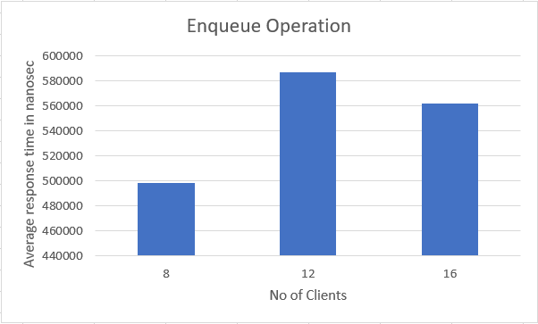

**Case 4**: Average Response Time for Dequeue Operation at the Server Side for the no of Clients.

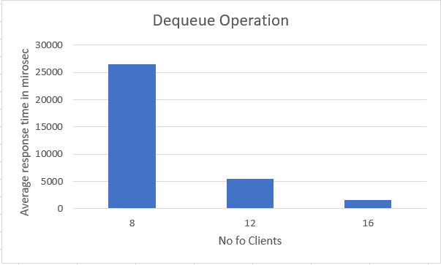

**Results**

